Exercise 1

Write a C++ Program that contains one user defined function *month()*.

* In main() function:
  + Read an integer input in between (1 to 12) and store it month_of_year.
  + Call month(month_of_year)
* In month() function:
  + Print the corresponding month of year in *month().*
  + Example: Value of parameter is 4… Print “April”.

**SOURCECODE:**

#include<iostream>

using namespace std;

void month(int);

int main()

{

int m,a,b;

cout<<"Enter Month Of Year: ";

cin>>m;

month(m);

return 0;

}

void month(int mon)

{

if(mon==1)

{

cout<<"\nThe Month Of Year is :January"<<endl;

}

else if(mon==2)

{

cout<<"\nThe Month Of Year is :February"<<endl;

}

else if(mon==3)

{

cout<<"\nThe Month Of Year is :March"<<endl;

}

else if(mon==4)

{

cout<<"\nThe Month Of Year is :April"<<endl;

}

else if(mon==5)

{

cout<<"\nThe Month Of Year is :May"<<endl;

}

else if(mon==6)

{

cout<<"\nThe Month Of Year is :June"<<endl;

}

else if(mon==7)

{

cout<<"\nThe Month Of Year is :July"<<endl;

}

else if(mon==8)

{

cout<<"\nThe Month Of Year is :August"<<endl;

}

else if(mon==9)

{

cout<<"\nThe Month Of Year is :September"<<endl;

}

else if(mon==10)

{

cout<<"\nThe Month Of Year is :October"<<endl;

}

else if(mon==11)

{

cout<<"\nThe Month Of Year is :November"<<endl;

}

else if(mon==12)

{

cout<<"\nThe Month Of Year is :December"<<endl;

}

else

{

cout<<"\nIt's not the Month Of Year \n Please Try Again"<<endl;

}

}

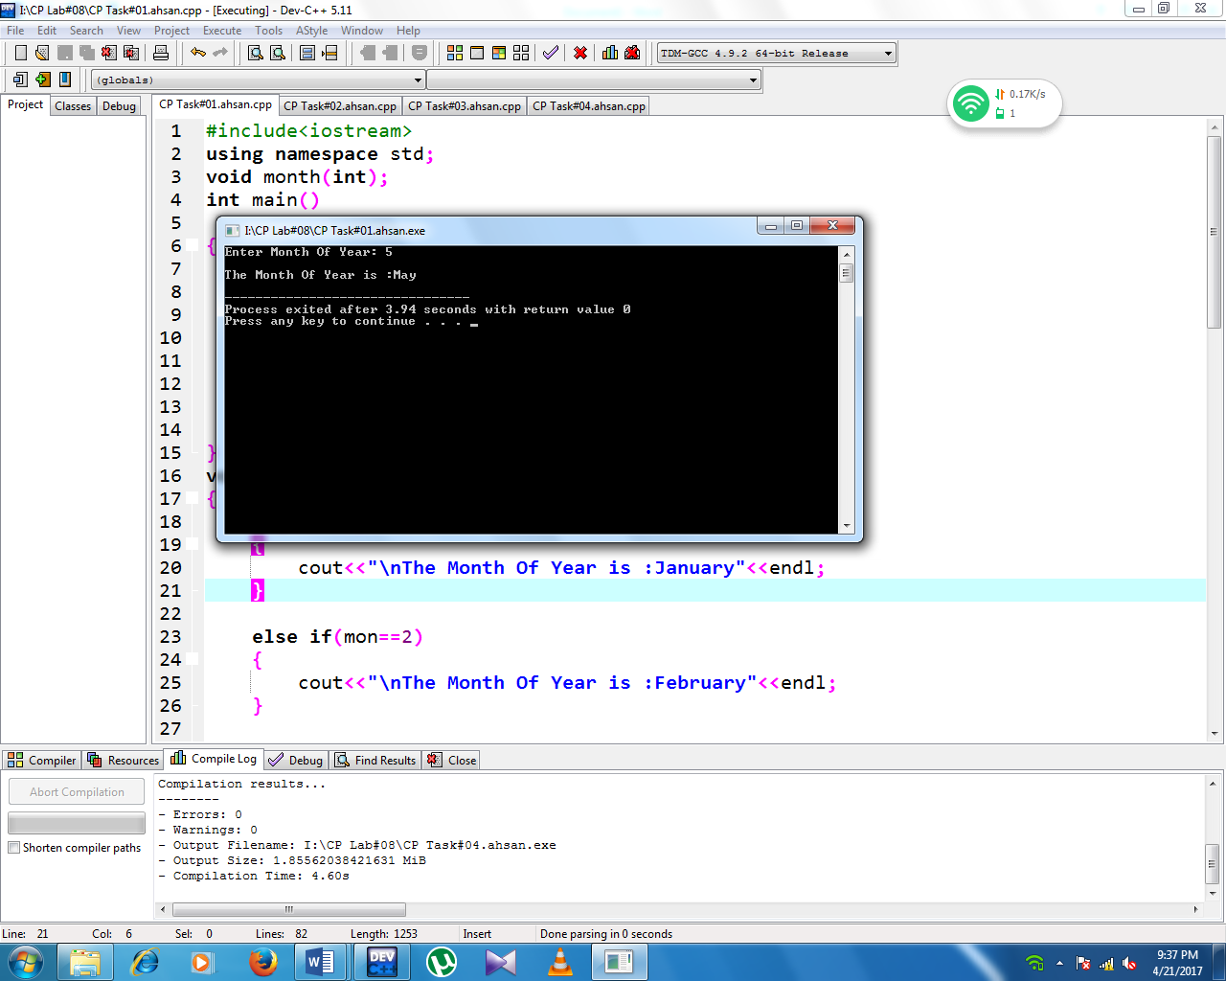**SCREENSHOT:**

Exercise 2

Write a C++ Program that contains one user defined function *cal_grades().*

* In main() function:
  + Prompt user to enter obtained(0 - 100) marks for one subject.
  + Call cal_grades(marks_subject).
  + Print the corresponding Grade with respect to Marks.
* In user defined function:
  + Perform conditioning with else if statement return char value.
  + Function must return value.

**SOURCECODE:**

#include<iostream>

using namespace std;

char cal_grades(int marks);

int main()

{

int a;

char gra;

cout<<"Enter Obtained Marks of student b\w (0-100) in one subject: ";

cin>>a;

cout <<cal_grades(a);

return 0;

}

char cal_grades(int marks)

{

char grade;

if(marks>=80 && marks<=100)

{

cout<<"\nGrade Of Student is:";

grade='A';

}

else if(marks>=70 && marks<80)

{

cout<<"\nGrade Of Student is:";

grade='B';

}

else if(marks>=60 && marks <70)

{

cout<<"\nGrade Of Student is:";

grade='C';

}

else if(marks>=50 && marks<60)

{

cout<<"\nGrade Of Student is:";

grade='D';

}

else if(marks>=0 && marks<50)

{

cout<<"\nGrade Of Student is:";

grade='F';

}

else

cout<<"\nEnter Correct number:";

return grade;

}

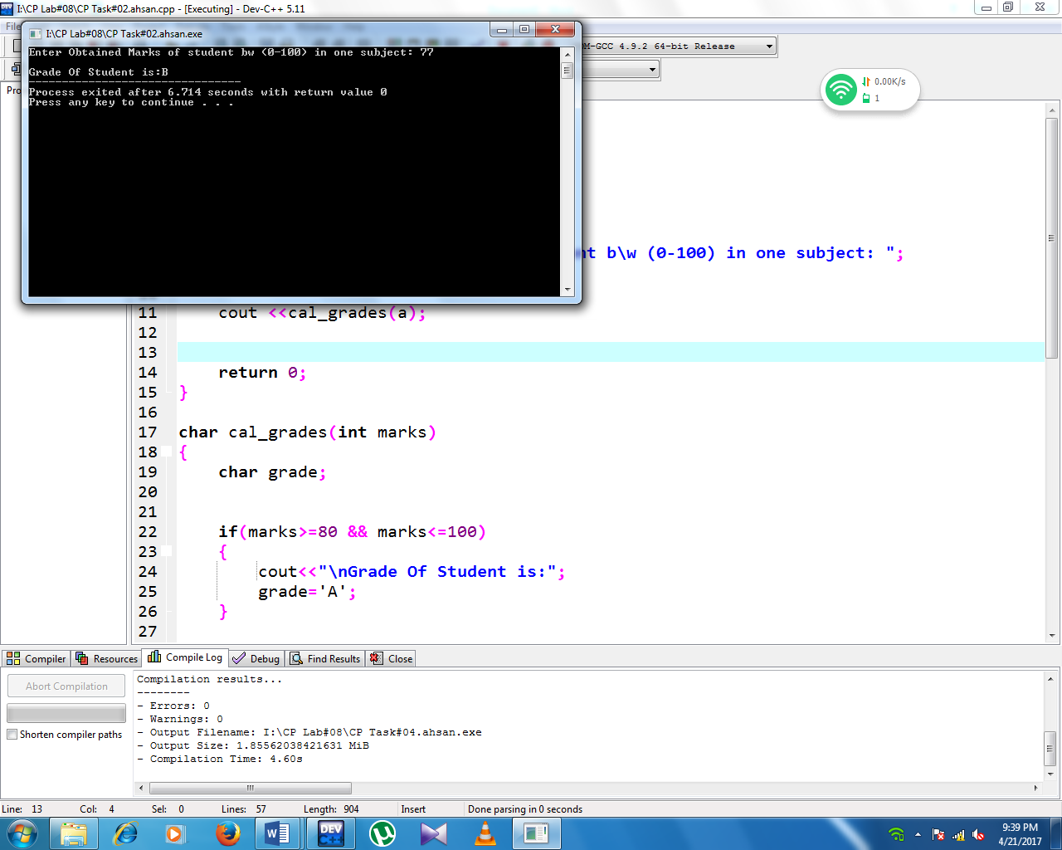**SCREENSHOT:**

Exercise 3

Write a C++ Program that contains four user defined function(s) *addition(), subtraction(), division(), multiplication().* Develop a calculator as follows:

* In main() function:
  + A menu with choices addition,subtraction,division and multiplication must be displayed.
  + Get two numbers and a choice from user
  + Call the respective functions with user given number as parameter using switch statement
  + Print the result from addition(), subtraction, division(), multiplication().
* In user defined functions:
  + Plus and Minus function get two interger values and return interger.
  + Multiply and Divide functions get two interge values and return float.

**SOURCECODE:**

#include<iostream>

using namespace std;

int addition(int i,int j);

int substract(int i,int j);

int division(int i,int j);

int multiply(int i,int j);

int main()

{

int a,b,c,d;

cout<<"Enter two numbers:"<<endl;

cin>>a>>b;

cout<<"\n1.Addition"<<"\t2.Substract"<<"\n3.Division"<<"\t4.Multiply"<<endl;

cout<<"Choose one of the above options: ";

cin>>c;

switch(c)

{

case 1:

{

cout<<"\nThe Addition of two numbers is: ";

cout<<addition(a,b);

break;

}

case 2:

{

cout<<"\nThe Substraction of two numbers is: ";

cout<<substract(a,b);

break;

}

case 3:

{

cout<<"\nThe Division of two numbers is: ";

cout<<division(a,b);

break;

}

case 4:

{

cout<<"\nThe Multiplication of two numbers is: ";

cout<<multiply(a,b);

break;

}

default:

cout<<"\nChoose Correct Option";

}

return 0;

}

int addition(int i, int j)

{

int sum;

sum=i+j;

return sum;

}

int substract(int i, int j)

{

int sub;

sub=i-j;

return sub;

}

int division(int i, int j)

{

int div;

div=i/j;

return div;

}

int multiply(int i, int j)

{

int mul;

mul=i*j;

return mul;

}

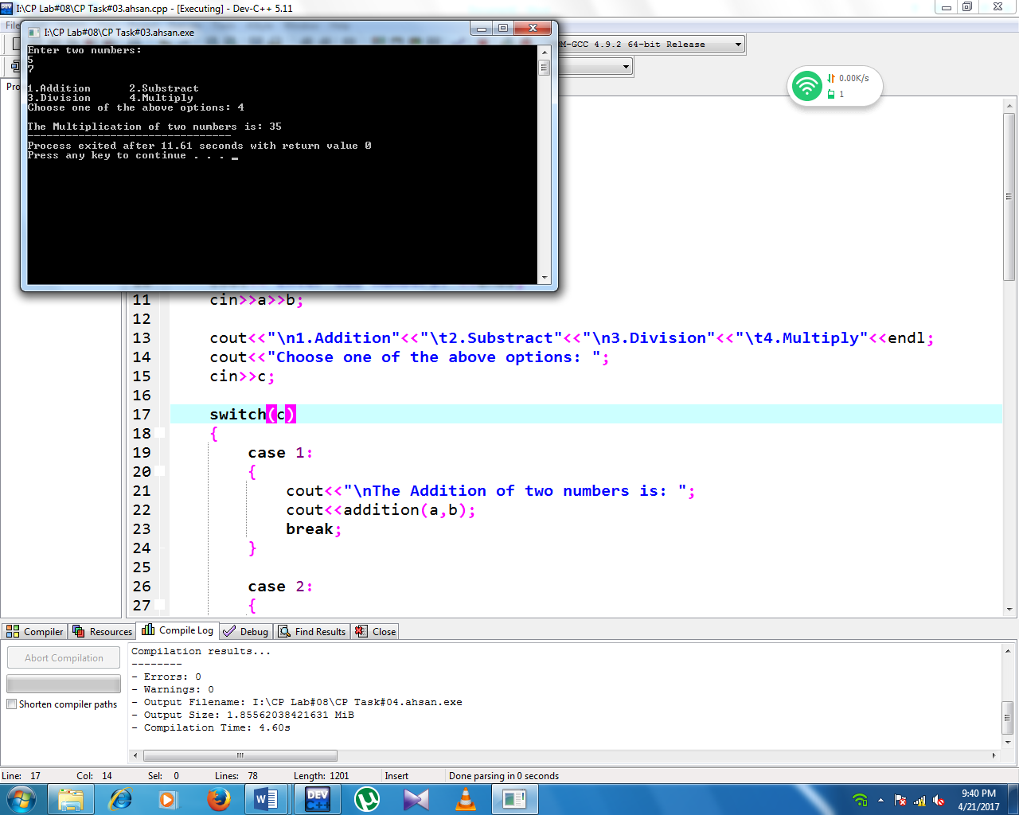**SCREENSHOT:**

Exercise 4

Write a C++ Program that calculates the power of a base by a user defined function as follows:

* Take the power and the base from the user in the main function.
* Calcuate the power of the base in a user defined function “MY_POWER” by passing power and base from the main ( ) to the MY_POWER function.
* Calculated value must return from the function to the main and display there.
* Print the result as follows:

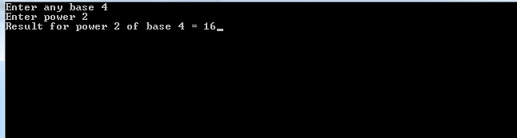

**SOURCECODE:**

#include<iostream>

using namespace std;

int power(int x, int y);

int main()

{

int a,b,c;

cout<<"Enter any base: ";

cin>>a;

cout<<"\nEnter power: ";

cin>>b;

cout<<"\nResult for Power ["<<b<<"] of base ["<<a<<"] = ";

c=power(a,b);

cout<<c;

return 0;

}

int power(int x, int y)

{

int po,i,j=x;

for(i=1;i<y;i++)

{

x*=j;

}

po=x;

return po;

}

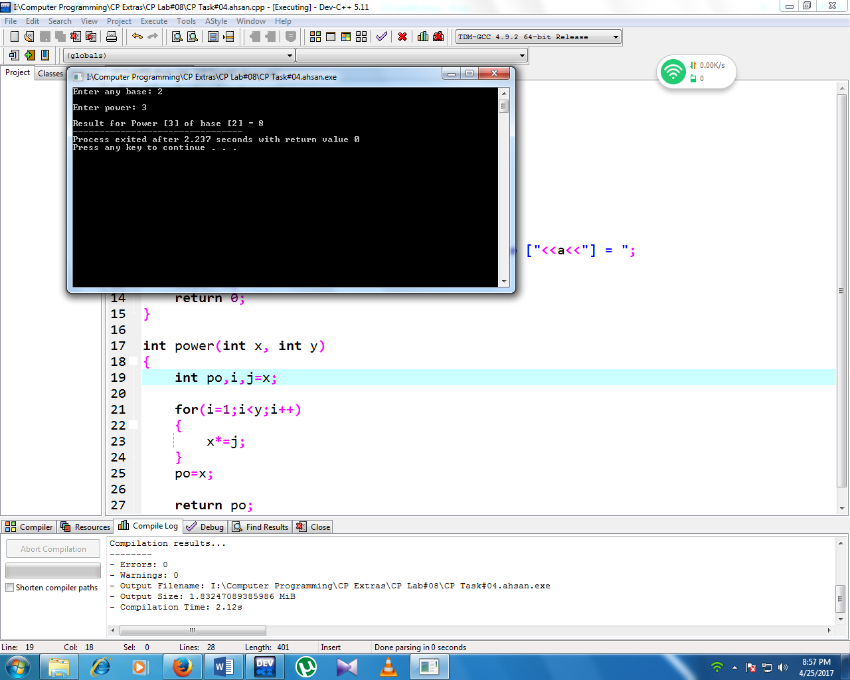**SCREENSHOT:**